ORDER the production of printed circuit number :

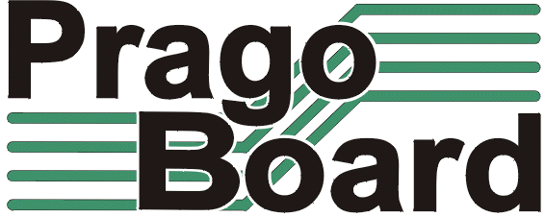

PragoBoard s.r.o.
Technologický park Běchovice
190 11 Praha 9 – Běchovice

IČ0 : 2561 5149
DIČ : CZ2561 5149
Customer :

Mode of transport :
Quation number :

We order :

Item nr. | Name of board | Nr. of pieces | Nr. Of layers | Material | Technology | Setup :  Film matrix | Delivery date
1.
2.
3.
4.
5.
6.
7.

Note :

Signature : Date :

