ORDER the production of laser SMT stencil numer :

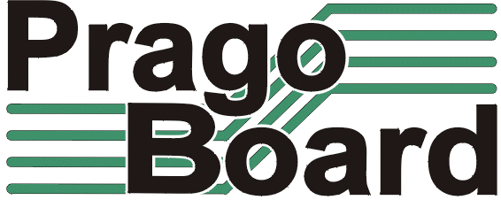

PragoBoard s.r.o.
Technologický park Běchovice
190 11 Praha 9 – Běchovice

IČ0 : 2561 5149
DIČ : CZ2561 5149
Customer :

Mode of transport :
Quation number :

We order :

Item nr. | Name of stencil | Nr. Of pieces | Stencil thickness | Format | Fiducials |  | Orientation  (Top, Bot) | Delivery date
 |  |  |  |  | NO/YES | through | Orientation  (Top, Bot) | Delivery date
 |  |  |  |  |  | 1/2 | Orientation  (Top, Bot) | Delivery date
1.
2.
3.
4.
5.
6.
7.

Note :

Signature : Date :

