RMA list no.:
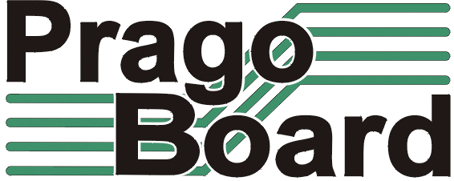

PragoBoard s.r.o.
Technologický park Běchovice
190 11 Prague 9 – Běchovice

VAT no. : CZ2561 5149

Customer:

Type of delivery:

PCB name:
Number of pcs reclaimed:
Job no. in PragoBoard (on delivery note):
Invoice no.:

Detailed description of the defect:

Date: ________________ Customers signature: _______________________

This part to be filled by PragoBoard:
Statement on the reclamation:

Date: _____________________ Signature of engineer: ____________________

PCBs delivered to customer: new / repaired / not-repaired / credit note *
Notes:

Date: ___________________________ Signature of supplier: _________________
* delete as applicable

